41. Count of Contacts - 31 May 2022

Count of Contacts / Rollup Summary in Trigger



User Story 1] Create a field “Count of Contacts” on Account Object. Show Total number of Contact in the Count of Contacts field of respective Account.

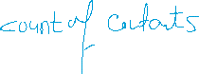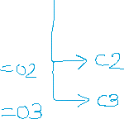

|  |  |  |
| --- | --- | --- |
| **Account** | **Count of Contacts** | **Child Contacts** |
| Cinemax | **03** | **C1** |
| **C2** |
| **C3** |
| Poonam Mall | **02** | **CP1** |
| **CP2** |
|  |



|  |  |
| --- | --- |
| Event | After |
| Operations | Insert, Update, Delete, Undelete |
| Trigger Object | Contact |
| Affecting Object | Account (DML YES) |

Not Optimized:

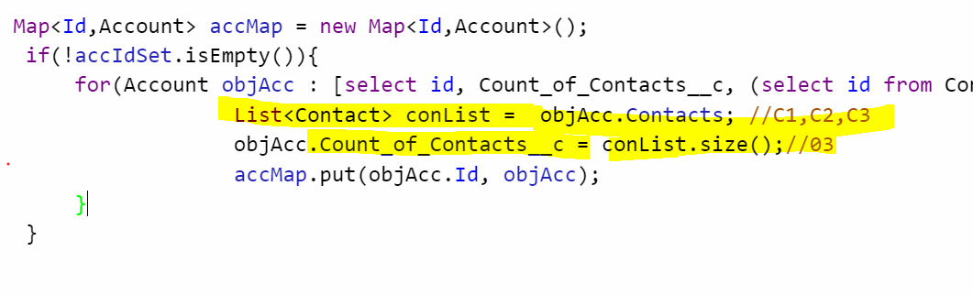

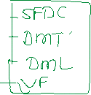

WAY 1:

trigger ContactTrigger31May on Contact (after insert, after update, after delete, after Undelete) {

Set<Id> accIdSet = new Set<Id>();

if( (trigger.isInsert || trigger.isUndelete || trigger.isUpdate) && trigger.isAfter){

for(Contact objCon : trigger.new){//C3

accIdSet.add(objCon.AccountId);//C3 = Cinemax

}

}

if( (trigger.isDelete || trigger.isUpdate) && trigger.isAfter){

for(Contact objCon : trigger.old){

accIdSet.add(objCon.AccountId);

}

}

Map<Id,Account> accMap = new Map<Id,Account>();

if(!accIdSet.isEmpty()){

for(Account objAcc : [select id, Count_of_Contacts__c, (select id from Contacts) from Account where Id IN : accIdSet]){//cinemax , C1,C2,C3

objAcc.Count_of_Contacts__c = objAcc.Contacts.size();

accMap.put(objAcc.Id, objAcc);

}

}

if(!accMap.isEmpty()){

Database.update(accMap.values(),false);

}

}

User Story 2] Create “Count of Passports” on Applicant object. Show total Passport on Applicant.

HINT : Child Relational Name : Addresses__r

objApp. Addresses__r.Size();

User Story 3] Create / Update Applicant Record. If Gender is Male, then Eligible for Police Verification.

After saving the record, send an email.

==============

**Gaurav Ka issue:**

Pin_Code__c (Number)

String str = String.valueOf(Pin_Code__c);

If(str.startsWith(‘44’)){

}